# Database Activity

Connect to your Windows VM and connect to the IP address of your Debian VM as follows (assuming the IP address of your Debian VM is 192.168.56.101)

<http://192.168.56.101/phpmyadmin>

You will need to log in. Please login as root with whatever database root password you set in your last activity

You will need to create a new database for future activities and assignments in this class. We will call this database **intro_database.** Once logged in, click on the Databases tab at the top of the web page:

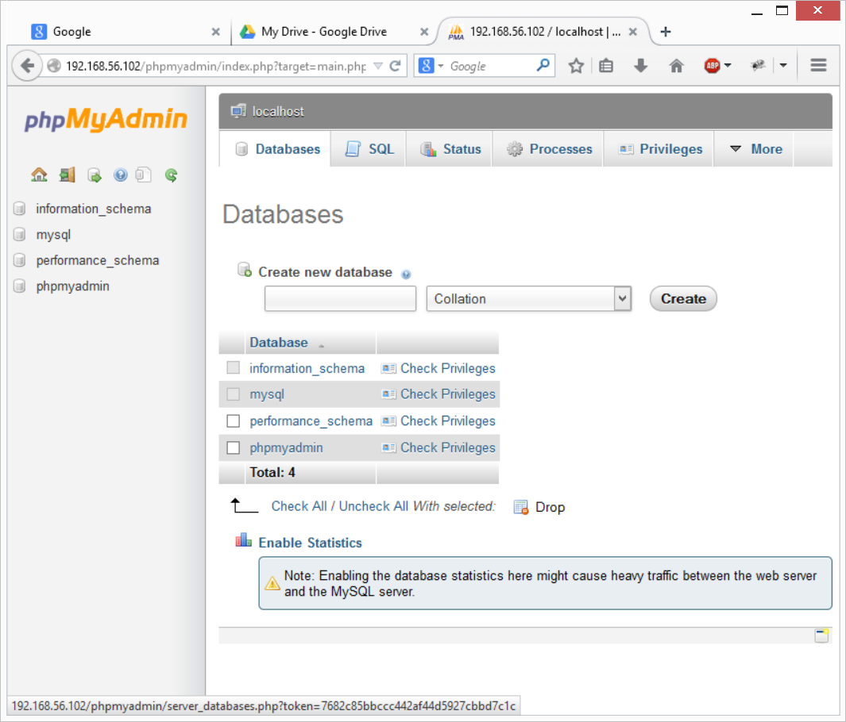

You may specify your new database now. Type in intro_database, leave the type to Collation, and click create. It will show the following:

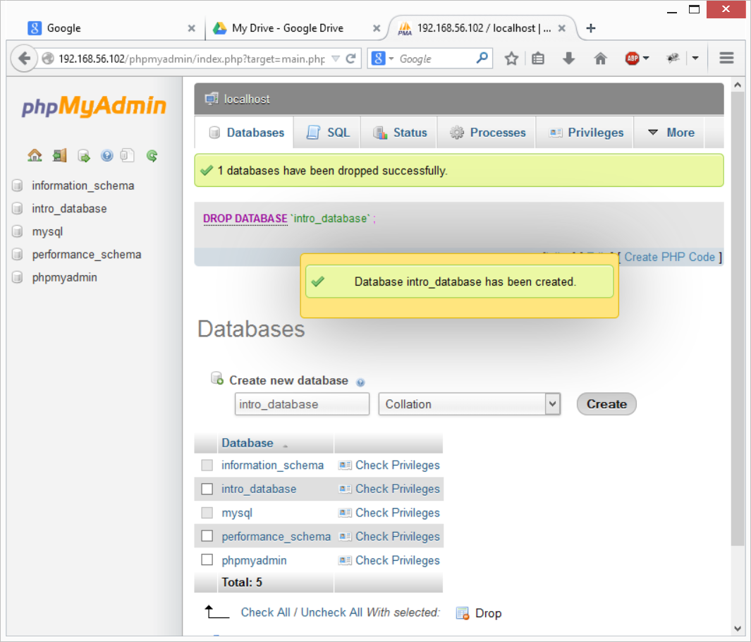

We can now click on that database along the left, and open it up to work on. Once selected, click on the SQL tab to copy/paste a block of SQL code

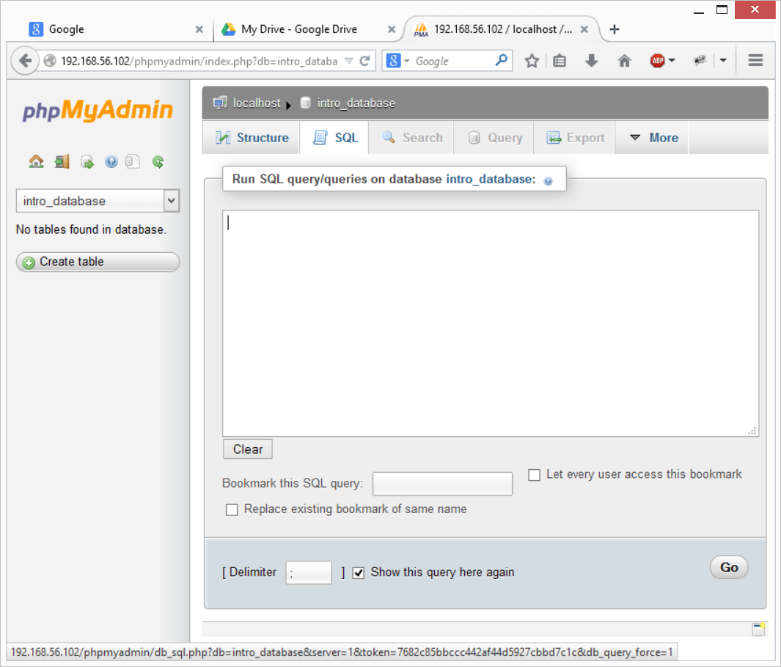

You can now open up the CreateDatabase.sql file (found in the same Dropbox folder as this document) in your preferred text editor. You can then select all text in the file (often Ctrl + A), copy it (Ctrl + C), and paste it into the SQL field in PHPMyAdmin, as below. Note you have approximately 280 lines of SQL code, so it will scroll off to the top.

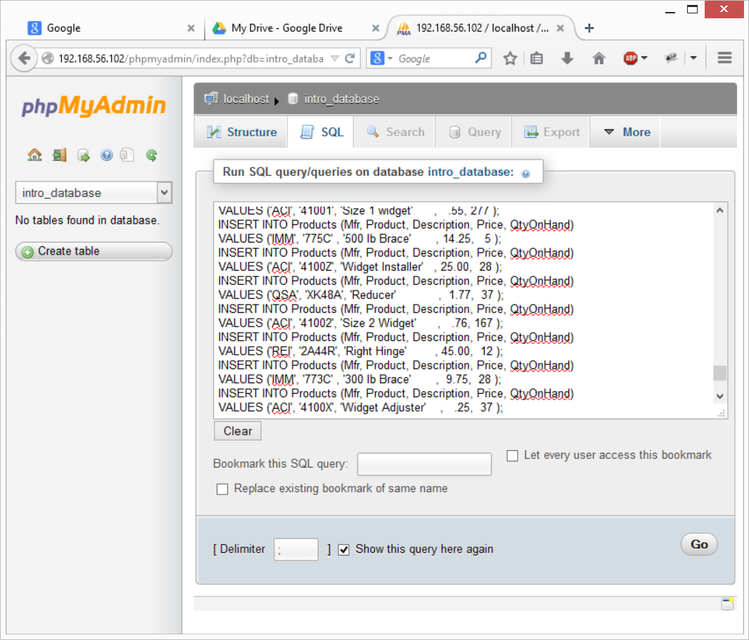

Click on the Go button, you will be prompted to confirm, click OK, and you should see no error messages. There is a refresh button top left, indicated with the orange circle below, which will refresh the table listings along the left. When clicked, you should see this a list of tables. When you click Structure tab, it should refresh the tab list to show more options. See below:

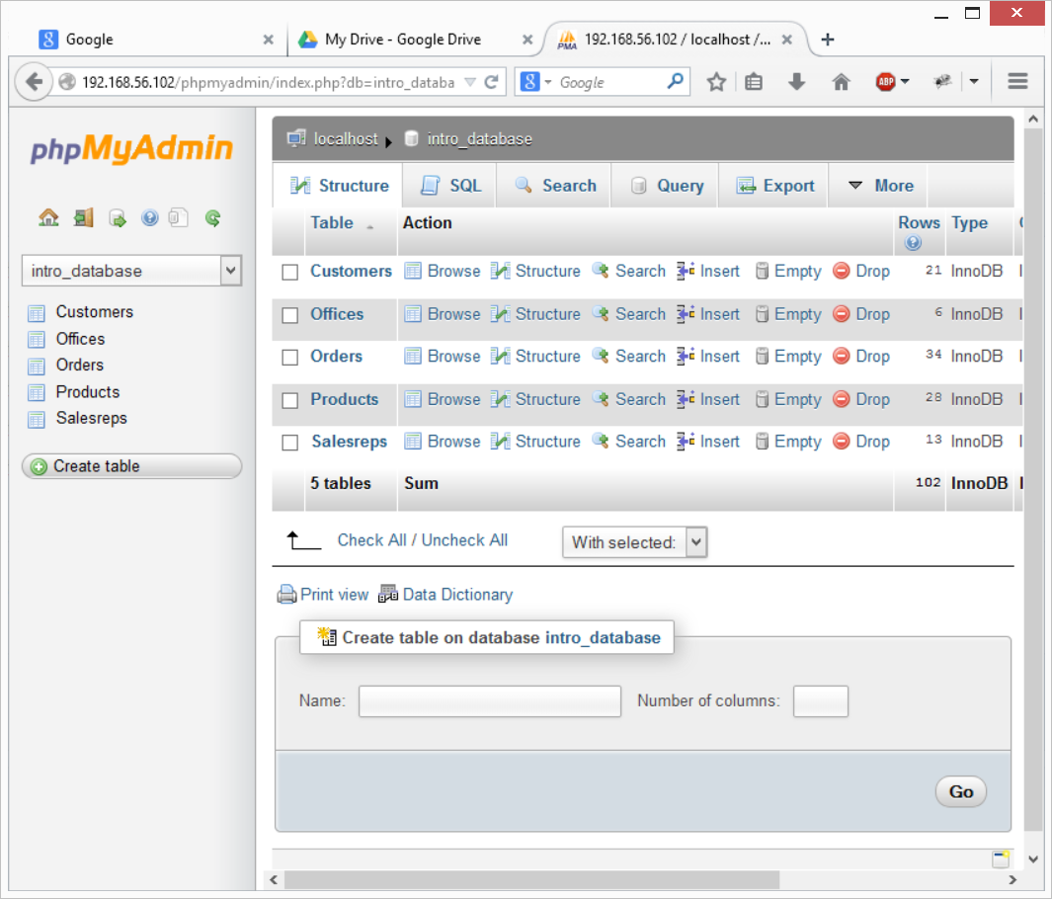

You can now click on each table, and view its content. We will be using the SQL tab on the intro_database database to run our queries.